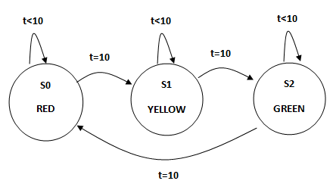

**module traffic_lights1 (clk, light);**

**input clk;**

**output [2:0] light; reg [2:0] light;**

**parameter S0 = 0, S1 = 1, S2 = 2;**

**parameter RED = 3'b100, GREEN = 3'b010, YELLOW = 3'b001;**

**reg [0:1] state;**

**always @(posedge clk)**

**case (state)**

**S0: begin**

**light <= YELLOW;**

**state <= S1;**

**end**

**S1: begin**

**light <= GREEN;**

**state <= S2;**

**end**

**S2: begin**

**light <= RED;**

**state <= S0;**

**end**

**default: begin**

**light <= RED;**

**state <= S0;**

**end**

**endcase**

**endmodule**

**`timescale 1s/1s**

**module tst_traffic_lights1;**

**reg clk;**

**wire [2:0] light;**

**traffic_lights1 tf (clk, light);**

**initial**

**clk = 0;**

**always**

**#5 clk = ~clk;**

**endmodule**

